**Lot 331 DP 1035434 Cobargo Bermagui Road, Cobargo (Austin)**

**Council workshop notes**

At the Council meeting held on 12 June 2012 Council resolved to include the land as an Appendix 3 matter being:

*“That in regard to Draft Comprehensive Local Environmental Plan Council adopts the recommendations for the submissions outlined in…:”*

* *“Appendix 3 - further research to be carried out by Council staff prior to progressing via a future report to Council; and…”*
* *“The request for a change in proposed zone to R5 has merit in the context of the Cobargo Village boundaries. However any proposed change in zone should not be considered in isolation but also include the land to the west. Decision to be deferred pending staff review.”*

The subject land is currently identified as a ‘Deferred Matter’ under BVLEP 2013 and consequently the provisions for the 1(a) Rural General Zone of Bega Valley Local Environmental Plan 2002 (BVLEP 2002) currently applies to the land.

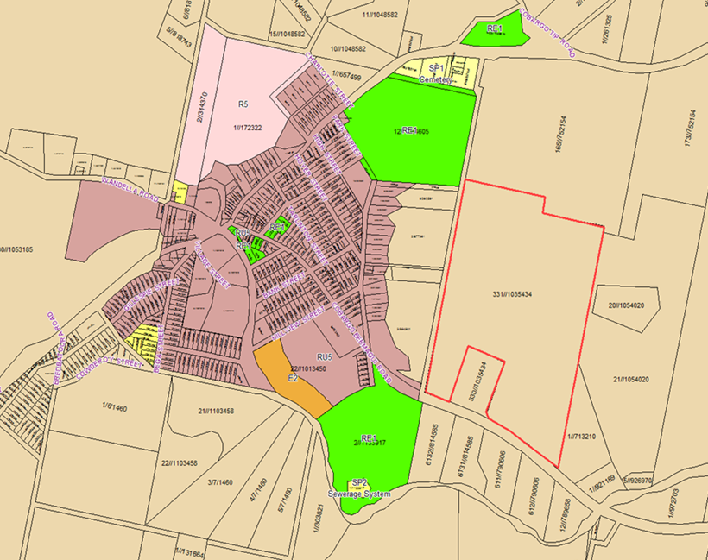

Figure 1. Draft BVLEP 2010 Zoning Map Cobargo Area

Submission summary

Lot 331 was proposed to be zoned RU1 Primary Production with a minimum lot size of 120 hectares under Draft BVLEP 2010 (see Figure 1). During the exhibition of Draft BVLEP 2010, Council received a submission from the Keeplan Planning Services on behalf of the owner of the property requesting an R5 Large Lot Residential zone with a minimum lot size of 3 hectares to allow for subdivision of 9 rural residential lots of 3.2 - 9.6 hectares (see Figure 2).

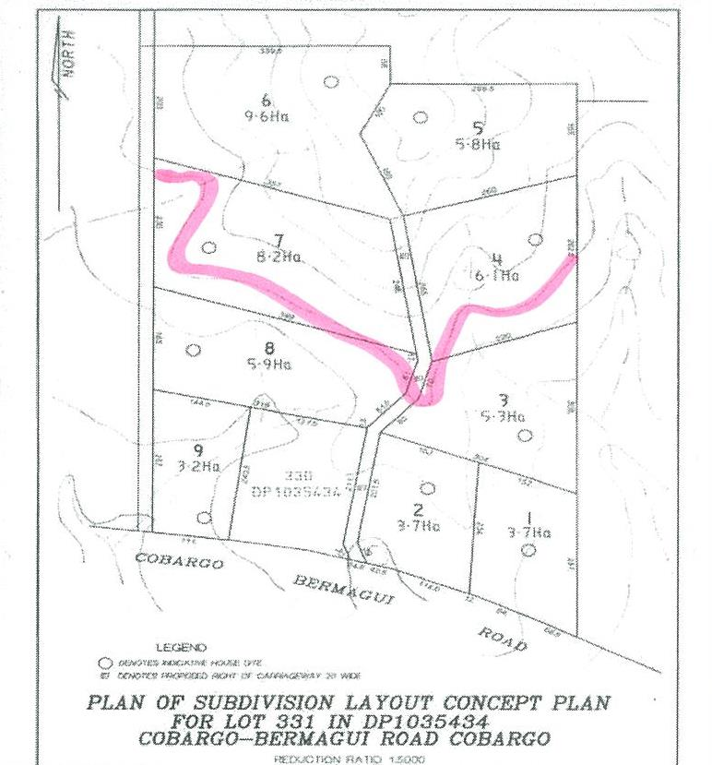

Figure 2. Proposed Lot Layout

Background

The subject land has an extensive background with Council, dating back to 1995, when the proponent originally sought a rezoning of the site from 1(a) Rural to rural small holdings. On 8th August 1995, Council resolved to include the subject land in the short term review for supply of rural small holdings in close proximity to Cobargo. Following this a Settlement Strategy review was conducted of the Cobargo area which sought to rezone the area adjoining the Cobargo village 1(c1) rural hobby farm zone and provide the supply of land for rural small holdings within the Cobargo area.

On 23rd March 1999, Council resolved to prepare Draft BVLEP 1987 (Amendment No. 121) to propose implementation of the 1999 Cobargo Draft Local Environmental Study on Rural Residential land supply and Lot 311 (formally Lot 6133 DP 814585) be considered for subdivision of up to 5 lots (4 having frontage to the Cobargo Bermagui Road and 1 residue lot to the north). However, this was rejected by the Department of Planning due to the cumulative impact of effluent disposal on the surrounding catchment.

In November 2001, Lot 6133 DP 814585 was subdivided into 2 allotments (Lots 330 and 331 DP 1035434) as per development consent no 2001.1147 for the purposes of 1 residue lot (Lot 330) and 1 agricultural lot (Lot 331) and presently has no planning avenues available under the provisions of BVLEP 2002 to subdivide the property.

Issues

* Effluent treatment and disposal

The 1999 Cobargo Draft Local Environmental Study on Rural Residential land supply identified that at the time, the Cobargo area was not serviced with a reticulated sewerage scheme, the majority of residences were serviced by septic tanks with absorption trenches, with some aerated septic tanks with local effluent irrigation systems. This raised concerns both from the local community and the EPA regarding the impact of effluent overflow from the absorption trenches and treatment and disposal of effluent.

The Cobargo village is now serviced by a reticulated sewerage scheme, which has reduced the cumulative impact of effluent overflow from absorption trenches.

The subject land is located outside the DSP area and has not been identified as an area designated for possible future expansion in Development Servicing Strategy, Population and Water Cycle Projections 2013 (see figure 3).

The proposed residential subdivision would have to manage and treat effluent onsite; however given the low density of the proposed development it would be considered to have minimal catchment impacts. An OSM assessment will be required as part of the Planning Proposal.



Figure 3. Cobargo Growth Areas

* Access

The 1999 Cobargo Draft Local Environmental Study on Rural Residential land supply identified existing access points from the Princes Highway have in some cases poor sight distances which not comply with RTA guidelines. The situation is worse in higher speed limit areas where required sight distances are much greater. The inability to provide safe and legal access is one of the major constraints for the development of this area. The study recommended as a matter of policy Council and the RTA seek to minimise additional access points onto major roads.

The subject land has an existing access off Cobargo Bermagui Road to the existing dwelling house on the lot. The property’s frontage to Cobargo Bermagui Road is located in a speed zone of 100km/hour.

At the time the submission was received, accordingly any entry road into the site required a sight distance of 225 metres in each direction. The property has a frontage of 467 metres to Cobargo Bermagui Road and a subdivision layout was designed that satisfied the requirements of the RTA Road Design Guide.

The RMS guidelines have since been changed and the design no longer satisfies the requirements for sight distance, therefore upgrade of the existing access or an alternative access will have to be considered.

* Land Demand

The 1999 Cobargo Draft Local Environmental Study on Rural Residential land supply identified that at the time, the demand for rural residential lots was based on dwelling approvals granted in the years 1995-1997. It was estimated that an average of 11 dwellings were approved for that period. The area to which the estimate applied is that within a 10km radius of Cobargo village but does not include the village itself, Quaama village and the 1(c) zone approximately 9km east of Cobargo on the Bermagui Road. Hence, an estimate of the 20 year demand was 220 lots.

At the time the submission was received, it was proposed that there was an undersupply of unconstrained large lot rural residential land in and around the Cobargo village and that Cobargo did not contain any identified rural residential zoned land surrounding the town and there was a market demand for such lots.

The current demand for rural residential lots is based on dwelling approvals granted over a 5 year period in the years 2009-2014. There were a total of 2 dwellings approved for that period. The area to which the estimate applies is all land within the locality of Cobargo excluding the land zoned RU5 Village and RU1 Primary Production under BVLEP 2013. Hence, an estimate of the 20 year demand is significantly less at only 8 lots.

Currently there is an area situated on the north eastern fringe of the village, comprising of 20.7 hectares (2 lots) zoned R5 Large Lot Residential with the potential for subdivision of up to 10 lots given the minimum lot size for the land is 2 hectares (see Figure 4).

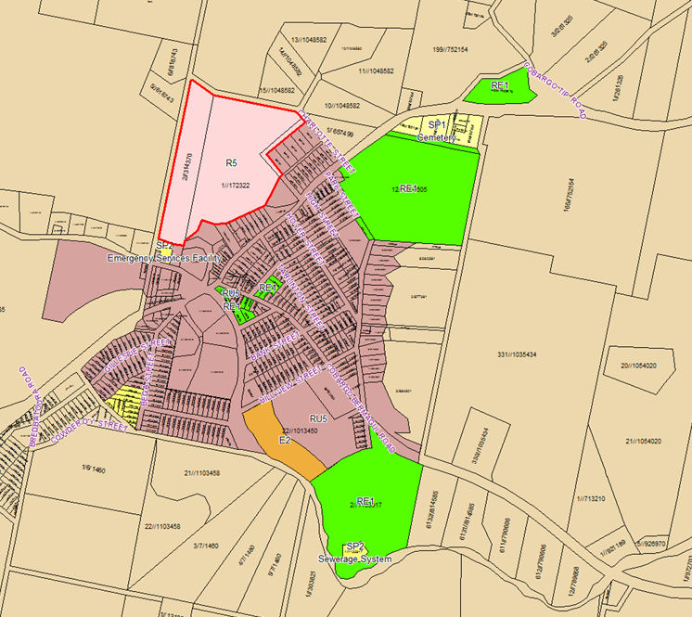

Figure 4. Draft BVLEP 2010 Zoning Map Cobargo Area

* Vegetation/Threatened Species

The 1999 Cobargo Draft Local Environmental Study on Rural Residential land supply identified the area of preliminary assessment has good quality agricultural land with a predominance of agricultural land of suitability Class 3 as identified by NSW Agriculture and was used for farming purposes. The study recommended this land should be retained for agricultural use where holding sizes are adequate and fragmentation should be prevented.

The Agricultural Classification of the subject land is Class 4-5 and therefore subdivision will not result in any loss of high quality agricultural 1-3 land.

The 1999 Cobargo Draft Local Environmental Study on Rural Residential land supply identified for the purpose of threatened species assessment in accordance with Section 5A of the EP&A Act, it is not expected that subdivision of the subject land into lots with a minimum average area of 5 hectares would result in an adverse effect on threatened species, provided that there are provisions for retaining existing tree cover, especially on creeks and gully lines, and encouraging the replacement of locally indigenous native vegetation.

Recommendation

On review Council staff consider a R5 zone with a minimum lot size of 5 hectares, to permit the development of up to nine rural residential allotments is appropriate for the land. Alternative access options will need to be explored including reconfiguring the lot design to utilise the single existing access off Cobargo Bermagui Road or possibly utilising the unformed Crown Road that runs along the western boundary.

The application of the lot averaging provisions of BVLEP 2013 Clause 4.1B would allow for a subdivision design with 3 smaller lots of approximately 3-4 hectares on the predominantly cleared land along Cobargo Bermagui Road and larger lots to the north to accommodate the moderately sloping topography of the land.